CATHOLIC FEAST DAYS APP

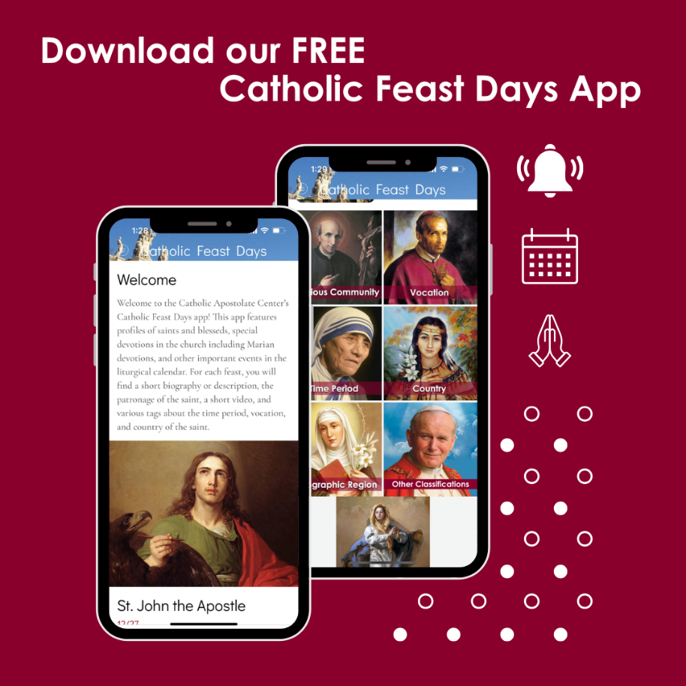

The Catholic Apostolate Center is pleased to announce our newest mobile resource, the Catholic Feast Days App. As a companion to the Church's liturgical calendar, the app serves as a comprehensive guide to feast days and solemnities, highlighting the lives of the saints, those who walked in the footsteps of Christ.

The app features over 200 saint devotions, each with brief biographies written by Center staff. These biographies are paired with simple reflections that encourage a brief moment for prayer during a busy day. With optional daily notifications, users can receive a gentle reminder to pause, reflect, and pray with the saint of the day. For those seeking more depth, the app includes direct links to Center's Feast Day Website, where additional biographies, prayers, and spiritual content can be found.

The app's interactive design allows feast days to be browsed and filtered by categories such as vocation, country, and time period. Whether you are looking to deepen your spirituality, celebrate special occasions, or simply learn more about the Church's heritage, the Catholic Feast Days App offers an engaging and accessible way to connect with your faith every day.
Download the app today on your mobile device at The Apple App store or Google Play

