Catholic Social Teaching: Option for the Poor and Vulnerable
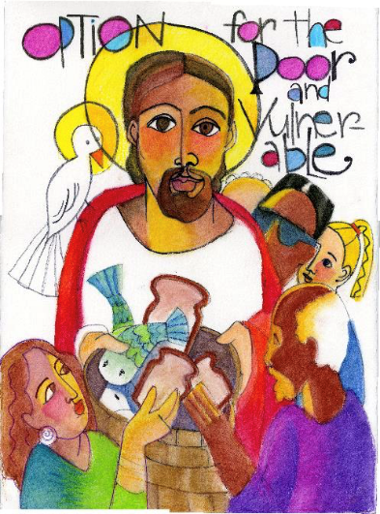

Introduction
The moral foundation of any society is determined by the well-being of its most vulnerable members. Catholic social teaching calls us to prioritise the needs of the poor and vulnerable, drawing an analogy to how a parent provides extra care and resources to a sick child to restore their health. As Christians, we are called to put the needs of those most in need first, recognising that those with the greatest needs require the greatest response.

From the Jubilee vision in Leviticus to the teachings of the Hebrew prophets and Jesus’ proclamation of his mission as “bringing good news to the poor,” people in poverty have always been central to the Judeo-Christian social vision. The poor are often forgotten, exploited, and marginalised, their dignity overlooked or abused. Their experiences reveal the shortcomings of social systems and provide crucial insights in the search for justice in society.

Responding to Poverty and Vulnerability
In societies marked by an increasing divide between rich and poor, the Gospel challenges us to practise radical and self-giving love. This means working to meet the immediate needs of the poor and vulnerable, while also opposing the systems and structures that perpetuate poverty and abuse. Our commitment must go beyond charity to include justice, ensuring that our actions and public policies always consider their impact on the poor and vulnerable. Whenever structural injustice exists, Christians have a duty to oppose it. The option for the poor is not an adversarial slogan, but rather a call to recognise that the deprivation and powerlessness of the poor harms the entire community.

The obligation to evaluate social and economic activity from the viewpoint of the poor and the powerless arises from the radical command to love one's neighbor as oneself. The option for the poor is an essential part of society's effort to achieve the common good. A healthy community can be achieved only if its members give special attention to those with special needs, to those who are poor and on the margins of society

Scriptural Foundations
Scripture consistently highlights the importance of caring for the poor and vulnerable:
- Exodus 22:20-26: Do not oppress the poor or vulnerable; God listens to their cries.
- Leviticus 19:9-10: Set aside part of the harvest for the poor and the stranger.
- Job 34:20-28: The Lord hears the cry of the poor.
- Proverbs 31:8-9: Defend the rights of the poor.
- Sirach 4:1-10: Do not delay in giving to those in need.
- Isaiah 25:4-5: God is a refuge for the poor.
- Isaiah 58:5-7: True worship is found in justice and care for the poor and oppressed.
- Matthew 25:34-40: What we do for the least among us, we do for Jesus.
- Luke 4:16-21: Jesus proclaims his mission to bring good news to the poor and oppressed.
- Luke 6:20-23: Blessed are the poor; theirs is the kingdom of God.
- 1 John 3:17-18: How does God’s love abide in those who see someone in need and refuse to help?

Church Teaching
The Church’s love for the poor is woven into its constant tradition. Inspired by the Gospel of the Beatitudes, the poverty of Jesus, and his concern for the poor, the Church extends preferential love to those oppressed by poverty. Despite the shortcomings of some of its members, the Church has consistently worked for the relief, defence, and liberation of the poor. The Church sees Christ himself in the poor, and this love is made concrete through the promotion of justice. (Catechism of the Catholic Church paragraph # 2444)

“Love for others, and in the first place, love for the poor, in whom the Church sees Christ himself, is made concrete in the promotion of justice.” (St. John Paul II, Centesimus Annus, no. 58)

The obligation to provide justice for all means that the poor hold the most urgent economic claim on the conscience of the nation. (United States Conference of Catholic Bishops, Economic Justice for All, no. 86)

"The needs of the poor take priority over the desires of the rich; the rights of workers over the maximization of profits; the preservation of the environment over uncontrolled industrial expansion; the production to meet social needs over production for military purposes." (United States Conference of Catholic Bishops, Economic Justice for All, no. 94 citing St. John Paul II's Address September 14, 1984)
"In teaching us charity, the Gospel instructs us in the preferential respect due to the poor and the special situation they have in society: the more fortunate should renounce some of their rights so as to place their goods more generously at the service of others." (St. Paul VI, A Call to Action [Octogesima Adveniens], no. 23)

“Faced with a world today where so many people are suffering from want, the council asks individuals and governments to remember the saying of the Fathers: 'Feed the people dying of hunger, because if you do not feed them you are killing them,' and it urges them according to their ability to share and dispose of their goods to help others, above all by giving them aid which will enable them to help and develop themselves." (Second Vatican Council, The Church in the Modern World [Gaudium et Spes], no. 69)

"Still, when there is a question of defending the rights of individuals, the poor and badly off have a claim to especial consideration. The richer class have many ways of shielding themselves and stand less in need of help from the State; whereas the mass of the poor have no resources of their own to fall back upon and must chiefly depend upon the assistance of the State." (Pope Leo XIII, On the Condition of Labor [Rerum Novarum], no. 37)

